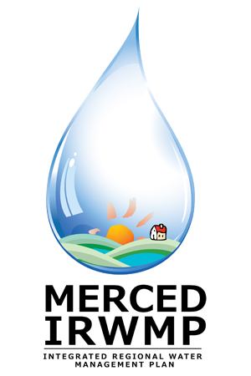

Merced Integrated Regional Water Management (IRWM) Plan
Public Workshop #3
Tuesday, February 26, 2013
6:00 pm – 8:00 pm
Cesar E. Chavez Middle School
161 Plainsburg Road
Planada, CA

- Welcome and Introductions 10 Min

- Meeting Purpose and Ground Rules 5 Min

- Introduction to the IRWM Program 25 Min

- Results of Technical Studies 20 Min

- Project Prioritization Process and Results 20 Min

- Merced Implementation Grant Application 20 Min

- Resources and Information 10 Min
- Questions and Comments 10 Min

